Resume Service Account

Version Control:

Use Case Name: |  | Resume Service Account
Use Case Owner: |  | Sumit Borade
Current Version |  | 0.1
Use Case Version History
Modified Date | Version |  | Modified By | Change Description
July 9, 2009 | 0.1 |  | Tom Schnarr | Initial Version

Brief Description:
This use case describes the process by which a YouSee subscriber’s services are resumed from SMP. This use case will be subsequently call the details of other use cases to resume those services.

Related Documents
- YouSee SMP SOW2Architecture Requirements Document
- YouSee SMP SOW2 Business Requirements Document

Related Use Cases
- Suspend Service Account
- Resume Broadband and Voice Service
- Resume Video service
- Resume mobile broadband service

Pre-Conditions
- Subscriber is currently a YouSee subscriber who’s account and services have been previously suspended

Post-Conditions
- All services for this subscriber have been resumed and the subscriber is again able to use the services.

Use Case

Primary Flow Diagram
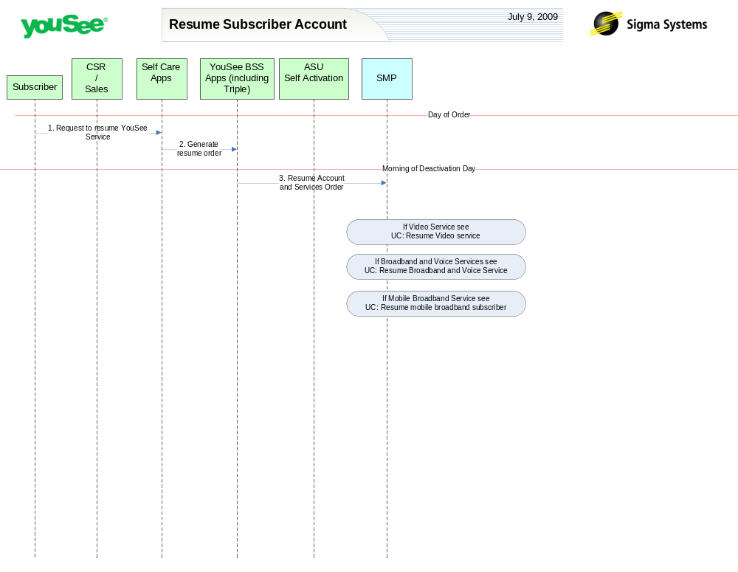

Primary Flow Detail
# | Actor: Key Action | Description | Alternate Flows/Details
Note: The first set of steps in this use case occurs on the day of order. This means the day the subscriber makes contact with YouSee to resume all services.
 | Subscriber: Contacts YouSee to resume services | Subscriber is currently a YouSee subscriber. They contact YouSee CSR team to resume service. | This event may also be triggered by automated processes such as billing non-pay jobs when the customer has paid past dues.
 | CSR: Order is created in YouSee BSS applications | YouSee CSR generates order for fulfillment in the YouSee BSS Applications  The BSS components perform a variety of qualification and product catalog decomposition and communicate an order to SMP defining the subscriber, address, candidate CPE and services as ordered by the customer.
Note: The next step occurs at the time that the installation order goes active, namely the morning that the deactivation is due to occur.
 | YouSee BSS: Order is communicated to SMP | YouSee BSS (Triple) will communicate the order to SMP through SMP’s Order Management API. Triple will provide logical services and service attributes. SMP will be required to translate these service/service attributes to engineering level resources and resource attributes.
Note: Depending upon the set of services ordered, secondary Use cases are implemented for those specific services. See the following Use Cases:
- Resume Video subscriber
- Resume Voice and Broadband over Cable
- Resume new mobile broadband subscriber

